Community Support Group Meeting List
Name and Type | Address | Meet Times | Additional Information
Recovery Alive  Faith Based 12-Step | East Pickens Baptist Church  2244 Gentry Memorial Hwy  Pickens, SC 29671 | Every Sunday  Free Dinner: 5 pm  Large Group: 6 pm  Small Groups: 7 pm | Has childcare and Youth Program  **Counts as 2 meetings if you stay for 2 hours
Celebrate Recovery  Faith Based 12-Step | Fellowship Community Church  1301 Greenville Hwy.  Liberty, SC 29657 | Every Thursday  Free Dinner: 6:30 pm  Group: 7 pm | Has childcare and Youth Program
New Life Women’s Group  Faith Based 12-Step | American Legion Post  185 Hagood St  Pickens, SC 29671 | Tuesdays at 6:30  **No meeting on last Tuesday of each month | Women Only  Contact: Michelle Alexander  864-419-2099
All Recovery  FAVOR | Brushy Creek Baptist Church  100 Clay St.  Easley, SC 29642 | Mon, Wed, Fri: 12 pm  Tues, Thurs: 6 pm | Contact: Chris Hendrix  864-385-5334
All Recovery  FAVOR | ZOOM | Monday – Saturday  12 pm | Contact: Chris Hendrix  864-385-5334
SMART Recovery | Queer Wellness Center–864 Pride  20 Pointe Dr  Greenville, SC 29615 | Monday: 6 pm | ZOOM and in-person  LGBTQ+ Friendly  Contact: Jamie Fivecoat  864-630-0473
Recovery Dharma  Buddhist Based | ZOOM | Thursday 12 pm | Through FAVOR  Contact: Chris Hendrix  864-385-5334
Never Use Alone Hotline | 864-484-3731 | 24/7 | You can call this number and use while someone is on the phone with you to decrease the risk of death from overdose. If you stop responding to them, they will send out emergency services to your address.
The NA Way  Narcotics Anonymous | Liberty United Methodist Church  310 Mae St.  Liberty, SC 29657 | Thursday: 7 pm
Chock Full O’ Nuts  Narcotics Anonymous | Saint Mathias Lutheran Church  501 Powdersville Rd.  Easley, SC 29642 | Wednesday and Friday:  7 pm
New Hope  Narcotics Anonymous | Grace United Methodist Church  309 E Cedar Rock St  Pickens, SC 29671 | Saturday: 8 pm | Go around back. The meeting is downstairs.
Pickens Community Group  Alcoholics Anonymous | American Legion Post  185 Hagood St  Pickens, SC 29671 | Mon, Wed, Fri, Sat:  7 pm  Sunday: 10 am
11th Step Easley  Alcoholics Anonymous | The Parenting Place  1039 S Pendleton St.  Easley, SC 29642 | Tuesday: 7:30 pm
Survivors Group  Alcoholics Anonymous | Eagle Eye Farms  102 Old Saluda Dam Rd  Easley, SC 29640 | Tuesday: 7 pm | Inside active barn. Dress accordingly.
Hope Group  Alcoholics Anonymous | Pickens County Shelter of Hope  145 City View Cir.  Pickens, SC 29671 | Saturday: 7 pm
New Life  Alcoholics Anonymous | St Andrew United Methodist  309 Pelzer Hwy  Easley, SC 29642 | Monday – Friday  12 pm
Winners Group of Easley  Alcoholics Anonymous | St Matthias Lutheran Church  501 Powdersville Rd  Easley, SC 29642 | Tuesday and Saturday  7 pm
Easley Survivor Meeting  Alcoholics Anonymous | Eagle Eye Farms  102 Old Saluda Dam Rd.  Easley, SC 29640 | Thursday: 7 pm  Saturday: 12 pm | Inside active barn. Dress accordingly.

How to Find and Join Online Meetings
- On your phone, go to bhspickens.com
- From the home page, select the 3 lines in the top right corner:
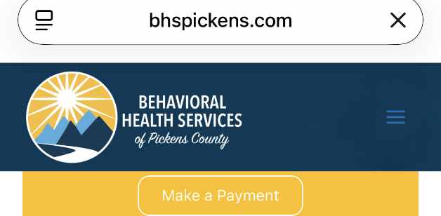
- From the menu that appears, select the arrow beside “Resources”
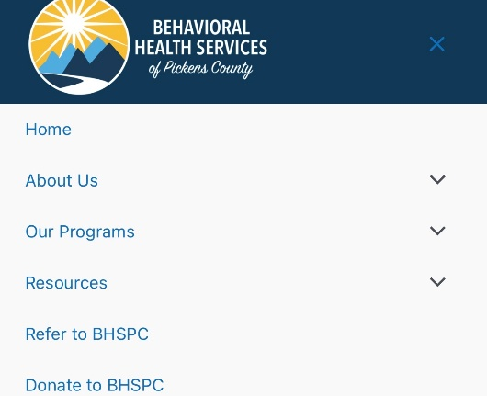
- Another menu will drop down. Select “Online Recovery Meetings”
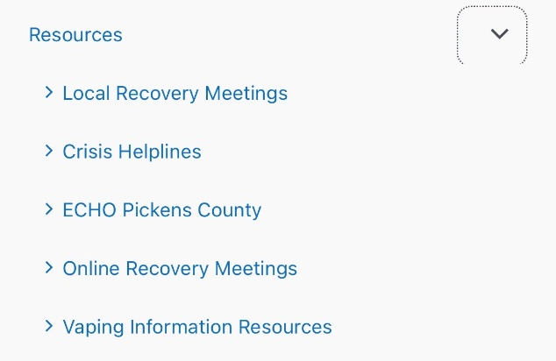
- A page will open with links to different websites where you can access online meetings
- Select the “Download Zoom” link and follow the instructions
- Return to the page with the links and select the type of meeting you want to join
- Find a meeting and select “Join”

